Open House Round #1 Summary
The first round of open houses for the Cottage Grove and St. Paul Park Small Area Plans was held in mid-July 2017. Approximately 20 people attended the Cottage Grove focused meeting on Tuesday, July 18th at the Park Grove Library. Approximately 25 people attended the St. Paul Park focused meeting on Wednesday, July 19th at St. Paul Park City Hall. A summary of the open house purpose, activities, and findings are outlined below.
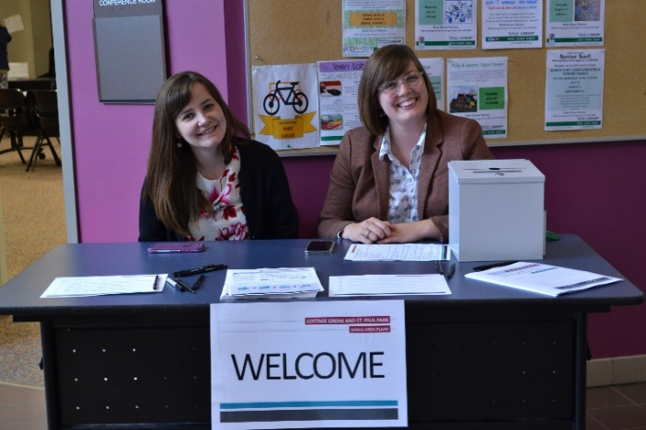 | 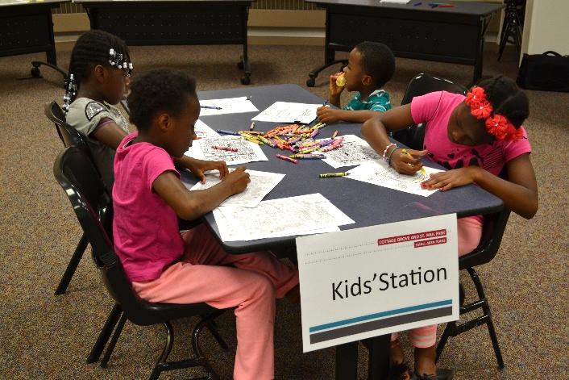

Purpose and Activities

Purpose
The purpose of the first round of open houses was to:
- Share existing conditions information
- Present market analysis
- Identify areas of change and areas of stability
- Identify opportunities and constraints within each small area
- Gain visions for the small area from the public

Stations
There were five stations at each open house. Staff was available at each station to lead a discussion on board content, to explain the activity, and to hear feedback from the public.
- Station 1: Project Overview. This station included boards with background information on the Red Rock Corridor for those unfamiliar with the corridor or bus rapid transit.
- Station 2: Existing Conditions. This station included boards showing the building and street network patterns in the small areas.
- Station 3: Suburban Transit-Supportive Developments. This station had boards highlighting examples of what transit-supportive developments look like in a Twin Cities suburban context.
- Station 4: Market Analysis. This station included boards showing population change and market trends in the small areas.
- Station 5: Your Community. This station had three activities to get direct feedback from the public. Attendees were asked the following prompts to learn their thoughts regarding the character of the small areas:
  - What is your favorite aspect of this area, or why do you like living or working in this area?
  - What is one aspect of this area you would like to see change?
  - Where is it currently challenging or uncomfortable to walk or bike?
For the first two prompts, responses were hung by clothespins to string so that other attendees could see and react to previous answers. For the final prompt, attendees marked their responses by placing a sticker on an aerial map of where they find it challenging to be a pedestrian or bicyclist and added additional comments on sticky notes.

Cottage Grove Findings

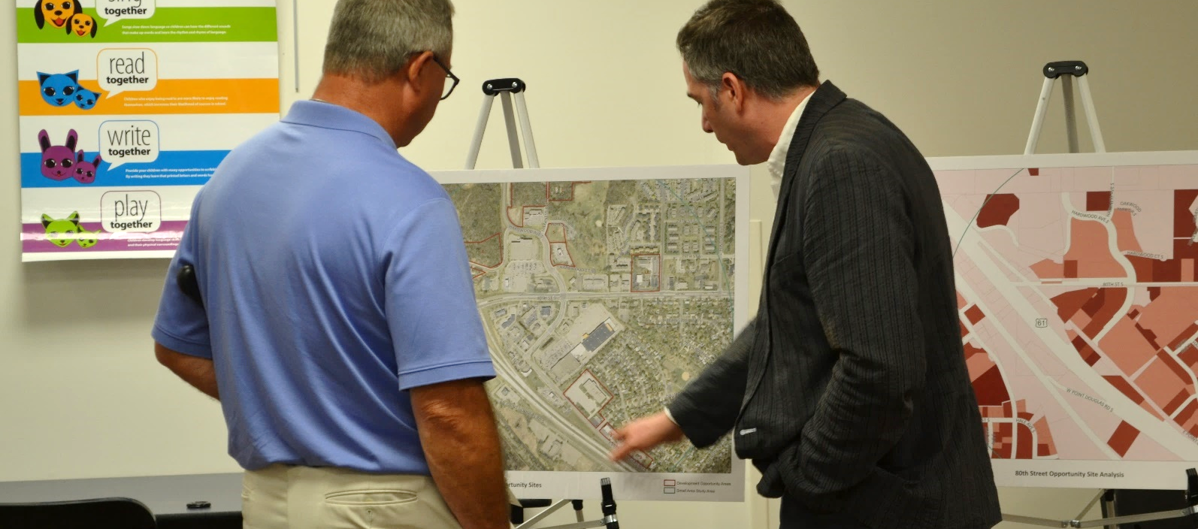General Comments
Some of the general comments that were heard at the Cottage Grove open house included:
- The current school district sites are underutilized
- Interest in where the money for the transit project is coming from
- Interest in seeing change in Cottage Grove
- Interest in when the Red Rock Corridor will be constructed and if it is definitely happening
- Interest in transit service connecting Hastings to Minneapolis and Saint Paul
- It is challenging to find apartments in Cottage Grove
- The express bus is challenging with children
- Why is commuter rail no longer an option?
- Appreciation for the market analysis information and that the small area plans will be grounded in market information
- What will happen to the express bus if BRT is introduced?
- Cottage Grove is currently very car dependent
- Connect the BRT to the Cottage Grove Park & Ride for increased convenience
- Concern about the addition of roundabouts because some people do not feel comfortable navigating them

Station 5: Your Community Feedback

What is your favorite aspect of this area, or why do you like living or working in this area?
Responses to this question noted that they enjoy their neighbors, their community, and that it is less busy than other parts of the Twin Cities.
This summarized response is a product of verbal discussion with staff and the five papers hung on the wall for this question. The raw comments provided by the public in response to this question were:
- “Bike/walk trails, parks/athletic areas most attractive in Twin Cities, more churches than bars, nice people.”
- “Todo esta tranquila (it is all tranquil/quiet).”
- “Less busy; more, smaller-scale business, good people, housing options/bigger house brought me here; mixed neighborhood (in age).”
- “Good people, location rural, & city open space.”
- “Post-office; previous location was better!”
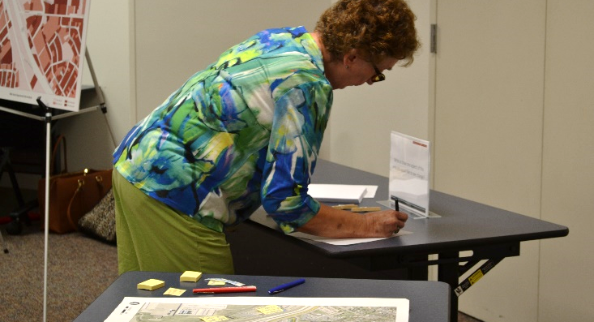 | 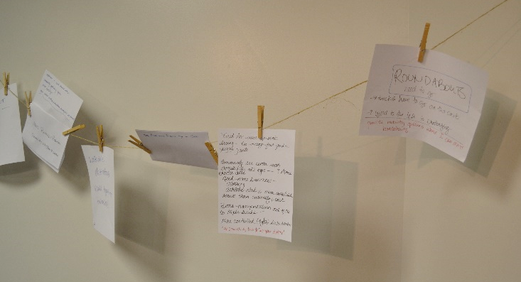

What is one aspect of this area you would like to see change?
Responses to this question noted that people desire a centralized community gathering spot supplemented by new retail or commercial options. Responses in general noted a desire for more variety in housing options, densities, and scales and types of commercial and retail activity. Several attendees envisioned going out to eat and having a place to walk around afterward.
This summarized response is a product of verbal discussion with staff and the six papers hung on the wall for this question. The raw comments provided by the public in response to this question were:
- “Retail – dress, clothing (Herberger’s ), more restaurant selection, River Oaks rest. could be better if promoted & more accessible, sporting goods/bait shop.”
- “Need more upscale dining – too many fast food & pizza joints. Community rec center with activities for all ages. Movie theater also. Need more business – clothing, athletic club & more available venues than currently exist. Better transportation out of CG to Mpls suburbs – more contested (lights) intersections.”
  - “Second all of this – new visitor!” (written by different individual)
- “Restaurant & walk around after. Community gathering space. Varied density. More similar to other suburban examples we showed.”
- “More retail and restaurants. Community UP/Place to gather.”
- “More business density – hub.”
- “Roundabouts need to go.
  - Trucks have to go on the curb
  - Yield to the left is challenging
  - Provide mobility options where I can avoid roundabouts.”

Where is it currently challenging or uncomfortable to walk or bike?
The most common mobility challenge highlighted in Cottage Grove was crossing Jamaica Avenue. Figures 1 and 2 depict where attendees identified challenging locations to walk (red dots) or bike (blue dots).
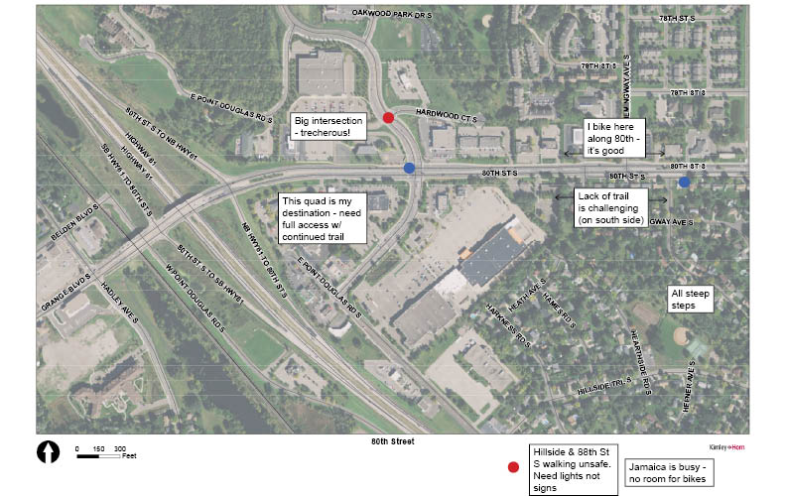
Figure 1: 80th Street Mobility Challenges

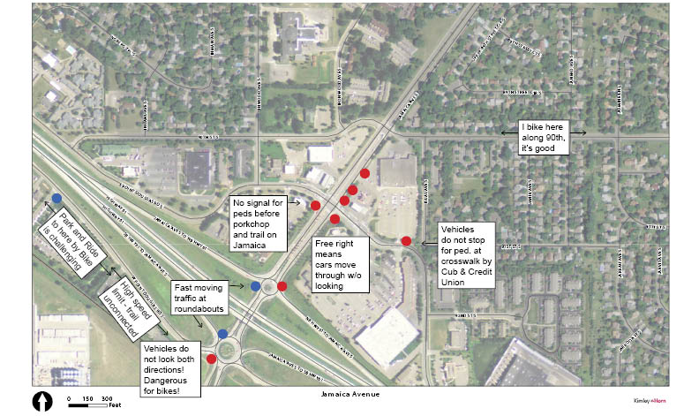
Figure 2: Jamaica Avenue Mobility Challenges

St. Paul Park Findings

General Comments
Some of the general comments that were heard at the St. Paul Park open house included:
- Concern regarding who would ride BRT to/from St. Paul Park (did not think there was a transit market near city hall)
- Perception that cars drive quickly on Hastings Avenue and do not slow down before the intersection of Broadway Avenue & Summit Avenue. This would be problematic for a station near this intersection

Station 5: Your Community Feedback

What is your favorite aspect of this area, or why do you like living or working in this area?
Responses to this question noted that they enjoy:
- The small town feel of St. Paul Park and that people know their neighbors
- The small businesses
- Housing affordability, particularly when compared to other suburbs
- Proximity to downtown Saint Paul, Woodbury, and Bloomington
This summarized response is a product of verbal discussion with staff and the nine papers hung on the wall for this question. The raw comments provided by the public in response to this question were:
- “Small town – get to know people. We know and like our neighbors.
  - Close to shopping areas, but it is not a shopping area itself.
  - Shopping areas are busy – keep elsewhere.”
- “When we moved here 20 years ago, one of the great features was knowing there is limited opportunity for massive housing development. After experiencing the on-going growth in California, we appreciate the small community, the opportunities of enjoying the river without paying association fees and the efforts of many in this community to make St. Paul Park a great place to live.”
- “Proximity to: downtown, airport. Small town feel. Near major highways – great location. Housing options – more affordable than other suburbs.”
- “Likes:
  - Easy to get around (most of the time)
  - Good schools when we moved here
  - Affordable housing
  - Small businesses – ‘love em’
  - Still has a ‘small town’ feeling”
- “Small town, close to the bigger cities. Close to establishments, walking distance. Duffy walking distance. Schools are great.”
- “St. Paul Park is not a large development area. Single family homes & smaller businesses is ok. Save the larger developments for our neighbor cities.”
- “The greatest joy of St. Paul Park is Duffy’s, the small businesses that are already here & the homes directly surrounding City Hall, and the colorful personalities that come from the Trailer Park.”
- “Community – I moved here to be with my friends and family.”
- “The community – people and activities.”
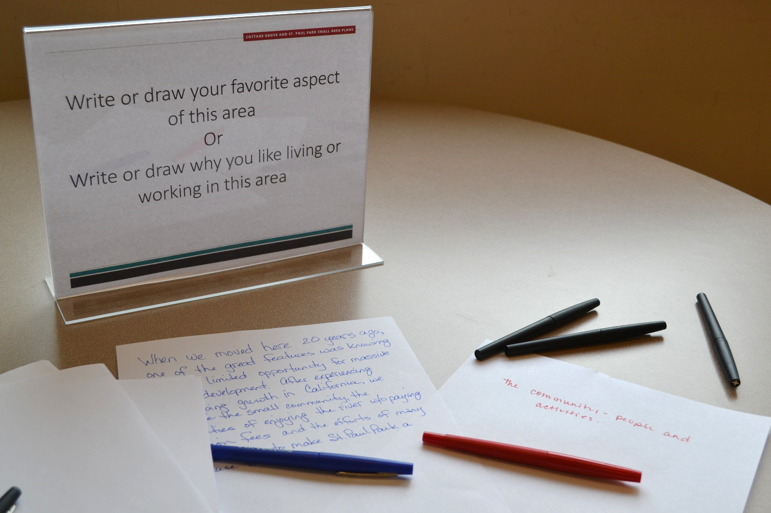

What is one aspect of this area you would like to see change?
Responses to this question noted that people desire a centralized community gathering spot supplemented by more walkable destinations and consistent, connected sidewalks. New commercial activity, such as larger-scale retail and medical clinics, was also requested.
This summarized response is a product of verbal discussion with staff and the 10 papers hung on the wall for this question. The raw comments provided by the public in response to this question were:
- “Community gathering space needed.
  - I go to Cottage Grove senior activities. It would be nice if it was closer or if I could get there by BRT.
  - More sidewalks, would be nice to be able to walk around!
  - Walkable shopping area
    - Bring back a small grocery store – local.”
- “The limited opportunity to increase revenue for city expenses falls on home owners. One thing I would like to see changed is creativity to generate more revenue for the city’s operation.”
- “Walkable destinations. Varied types of businesses!!”
- “Nothing! I like it the way it is. Not any crime and a nice peaceful community.”
- “No development @ site #8 or expand it to Portland Ave.”
- “St. Paul Park Road & Summit Ave – needs to regulate traffic better! Signal?”
- “Medical facilities are needed. Clinic – with good doctors – that you can get to easily.
  - I go to Walgreens/Cottage Grove for prescriptions. Would like something closer.”
- “Transit suburb to suburb. East to west through 494.”
- “Larger-scale retail… need more!”
- “Sit down restaurant.”

Where is it currently challenging or uncomfortable to walk or bike?
One mobility challenge highlighted in St. Paul Park is that the sidewalk network is disconnected and inconsistent. People also have concerns for pedestrian safety at the intersection of St. Paul Park Road & Summit Avenue given the frequent semi-truck traffic. Figure 3 depicts where attendees identified challenging locations to walk (red dots) or bike (blue dots). 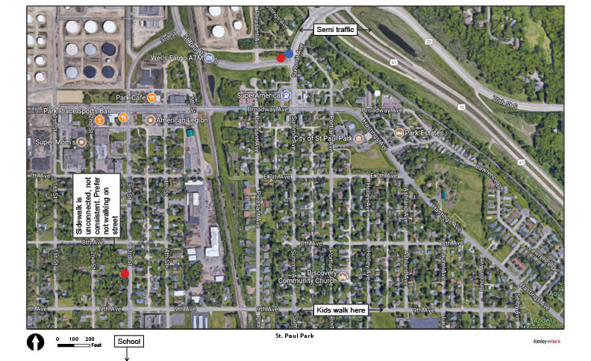
Figure 3: St. Paul Park Mobility Challenges

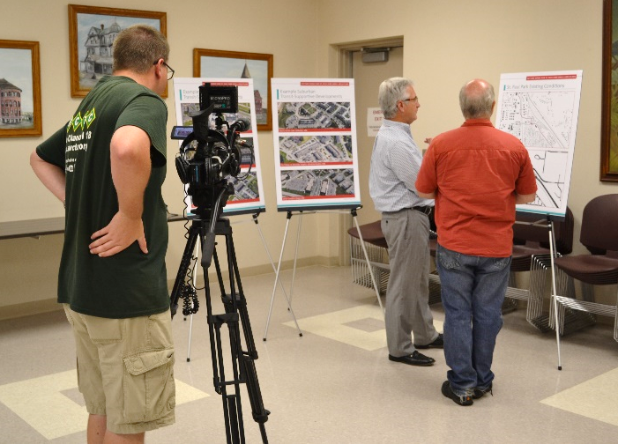 | 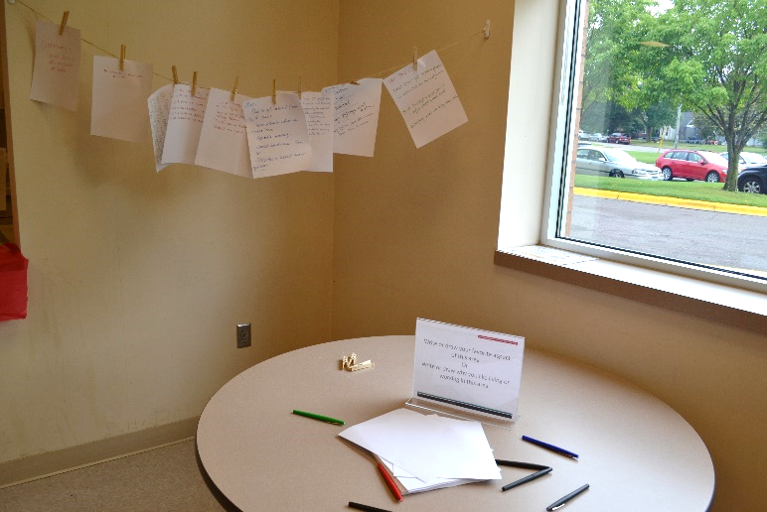
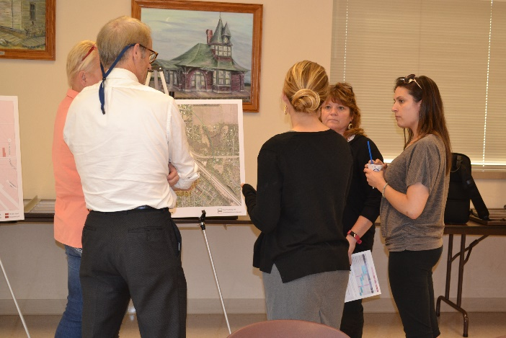 | 